***DB Connection Information***

Database name: web_final_db

Username = root

No Password

***Install Information***

* Step1: In MySQL administrator, create a new database, name "web_final_db".
* Step2: Import data with "web_final_db.sql".
* Step3: Check database user. In order to connect "web_final_db", the user name must to be "root" and without password.
* Step4: Unzip "CKH_finalP.zip" and put the folder "CKH_finalP" at the localhost folder of XAMPP. EX: C:\xampp\xampp\htdocs\CKH_finalP
* Step5: Open the website in browser. EX: http://localhost/CKH_finalP/index.php

***User Manual***

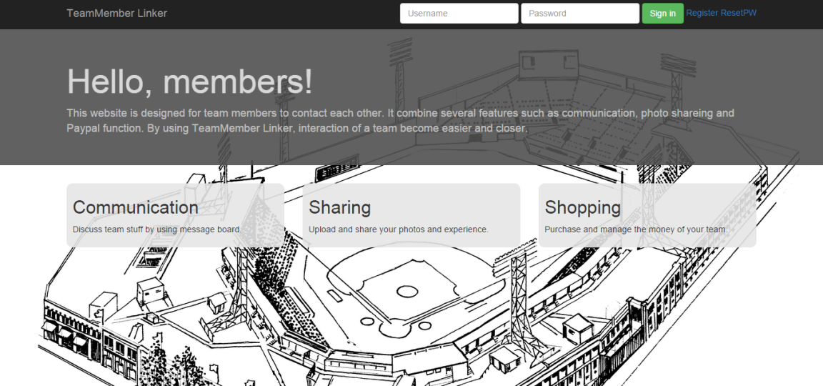

index page

First, user can create a new account by click "Register" link or enter directly with test account(username: test password: test)

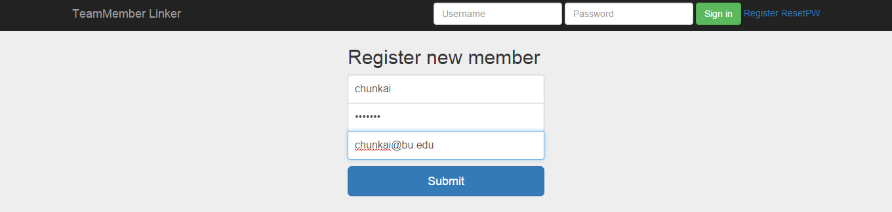

register page

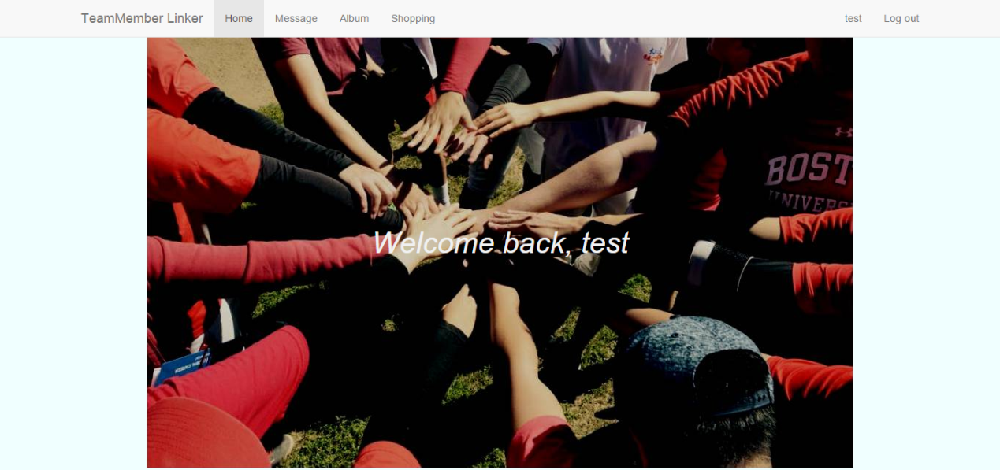

main page

The navibar on the top can direct to different pages.

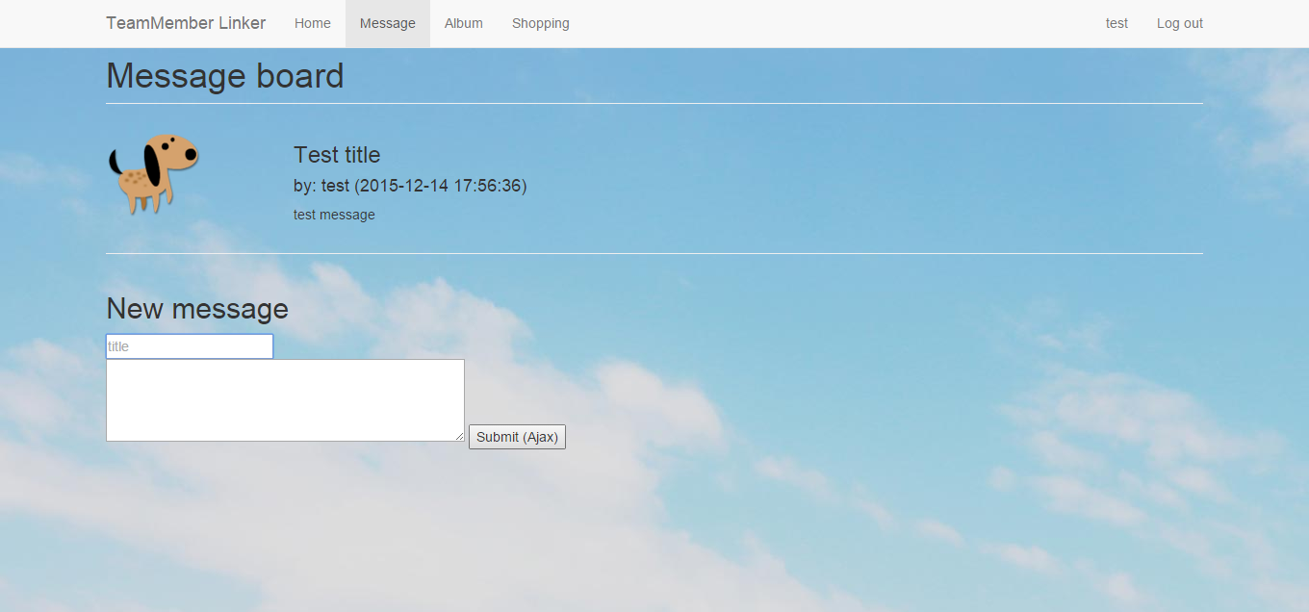

message board

Users can leave message on this page. Every time when users enter this page, all the message will show up.

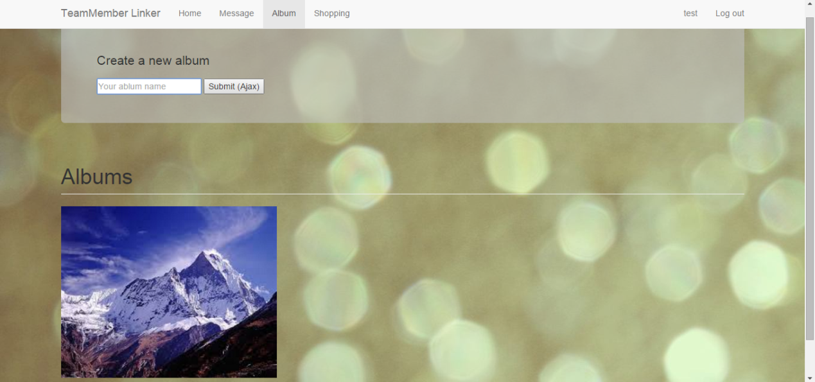

album page

Users can create new albums, enter a album name and click "submit", a new album will appear.

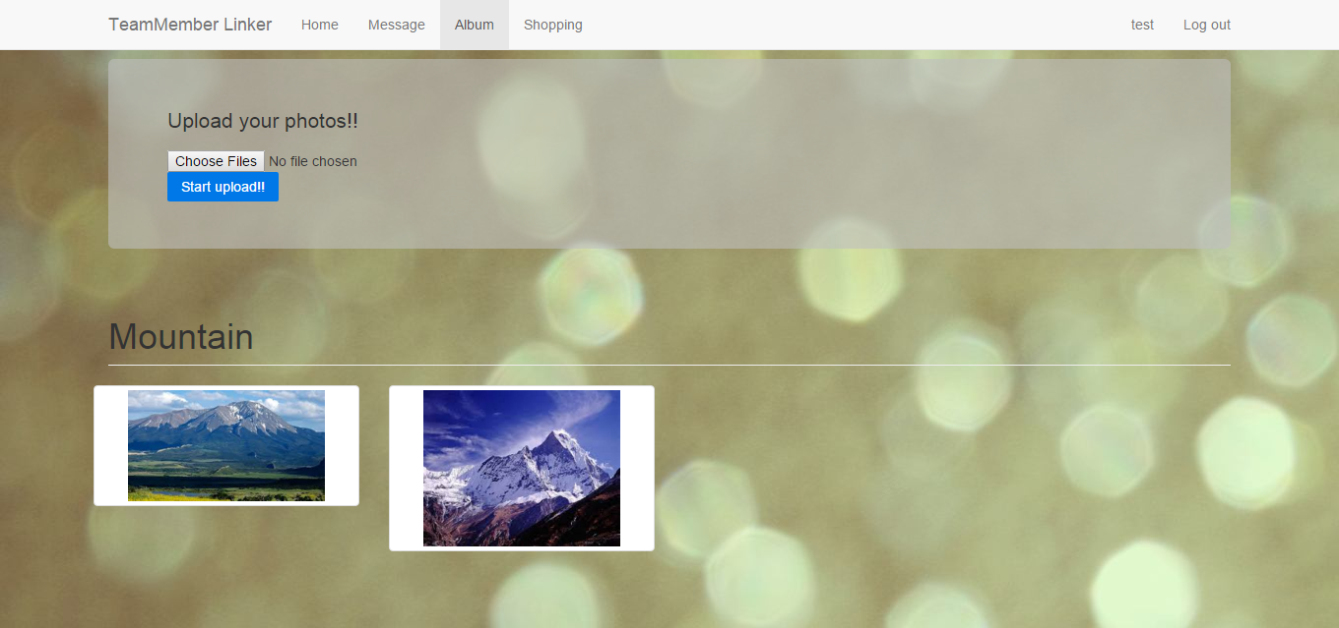

photos in a album

Click a album, and upload photos to the album. Click "Choose Files" and select photos. Then, click "Start upload".

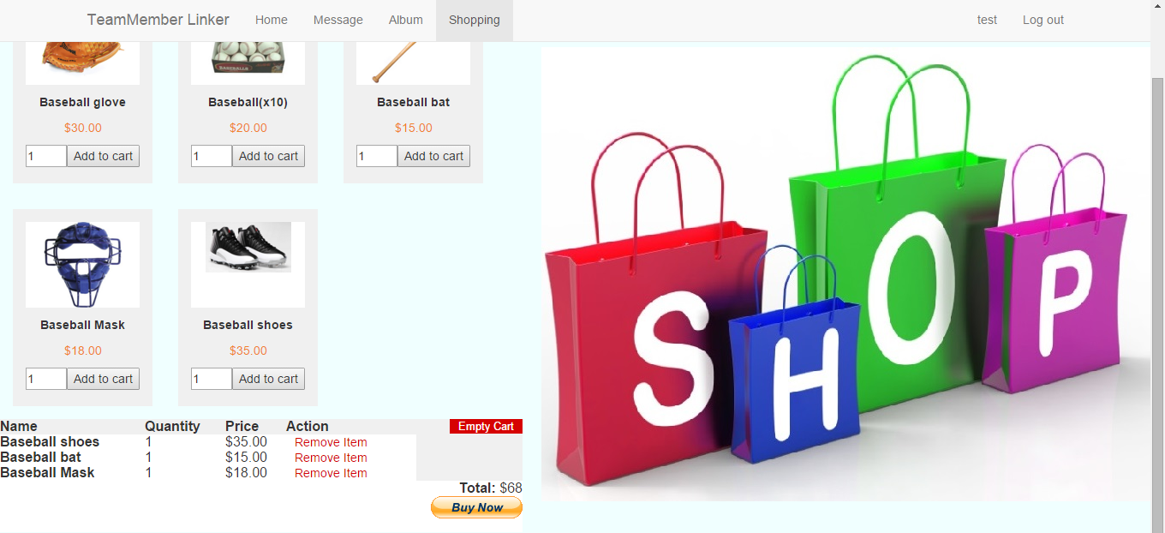

shopping page

Select quantity and click "Add to cart", a shopping cart will show up on the bottom of this page. When finish, click "Buy Now" to check out with paypal.

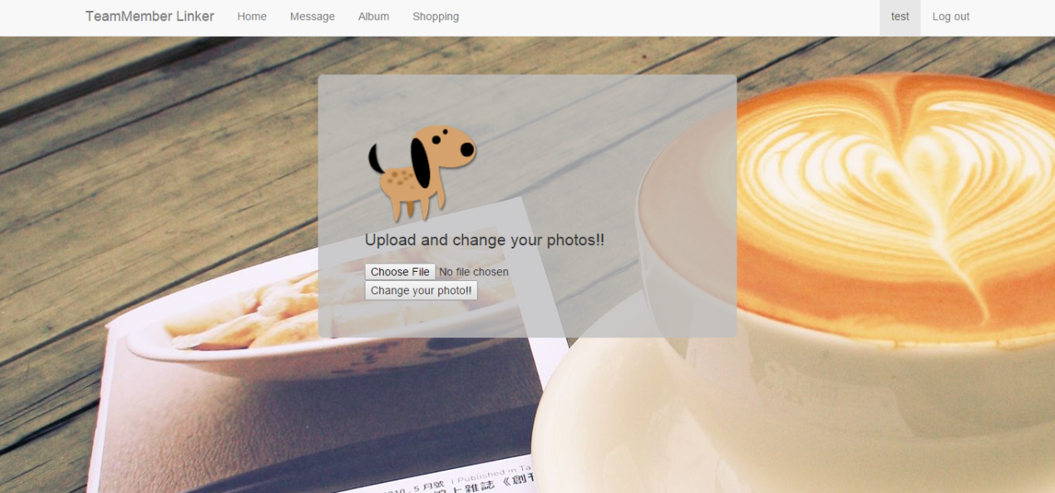

Upload and change sticker

Every user can upload their personal sticker, click "Choose File" and select a photo, then click "Change you photo!!".